® **j**-**sl**-**lmeo** ------

***AM mDrl of lfl• Cold* A..h *G,oup* Registration Routing Slip**

Date: **1... t..** -, *'i*

* Orculate To

Asst. Manager Div.Mgr.-Eng

-Metals

-Minerals

-Personnel Financial Acct.

Cost & Mngmnt Acct. Supt. W/House

Asst. Secretary

Chief of Loss Control Manager's Secretary Resident Secretary

No.

*1/* I *)*

----

Remarks

Initials

*-"'*-*V/*

Date

*-* ***1 ,*** Q - *C* - ?

*;J///1*

w.). *I* L,,-- ·Jv..

<-

-- *h«jf*

***r--,;n.J.*** *7*,*l.*,, *I* ~ *I*

**,t..,e_ /4**

.

***?,u;-,. a***

*(,' ,.,.J* vj}/-'J;;,. .

*Vt--,-* , ./

***k_ /'41 :J.* ///,4-,.<_..** *,../) /)-*

1989-04-24 15:26 MINTEK RANDBURG 011 7932413 P.01

**MINTEK**

# COUNCIL FOR MINERAL TECH OLOGY

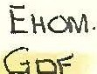rAx No: to1.1) 793-2413

# To: Man<

r· :

**TELEFAX $$AGE**

# Metals Production

T$U Corporation

p o tao 40

TSU$ 9000

:I I

# s.w. ./Namibia

{ .

;

fAX NO: 0( 71-3710 ATTENTION: Mr E.H.O. Meyer



# Please re eive the enclosed draft minutes of our recent sponsor's meeting

FR.OM: **A.F;s.** _Schoukans DIVISION: Pyrolttetallurgy EXT. NO. 309

S.IGNATURE ;OF SENDER *//;tu.Ael!J*

PROJECT NO: 06687/4B

TIME RECEliVEO BY REGISTRY!/0-li.::Q,I,?/ NTEK REFERENCE No, - *.?,?,*G

DATE RECE VE,D BY REGISTRY: *ii=ffa0,P4L* NO. OF PAGES TO FOLLOW: 5

AUTHORISED: (Signature of Head of Division if

required) .



1989-04-24 15: 26 MINTEf< RANDBURG 011 7932413 P.02

COUNCIL FOR MINERAL TECHNOLOGY P ROMETALLU GV DIVisioN

DRAFT MINUTES OF SPONSOR'S MEETING ON THE PROJECT

LASMAFUME 06687, HELD ON 18TH APRIL, 1989, AT

09HOO IN THE PYROMETALLURGY MEETING ROOM, MINTEK

Present: See attendance register attached

The major points which were raised after the presentations of Messrs Sahoukens, Erasmus and Visser were as follows:

l. Mr Meyer mG?ntioned that, in order to compete with con­ ventional fuming processes, the zinc and lead extractions should be in excess of 90 per cent; the germanium >.:­ traction via the fume should be higher than 80 per cent. Mr Meyer then asked if the Tsumeb slag fuming process in a plasma-arc furnace can be operated without metal form­ ation.

1. Dr ·Jochens suggested the use of composite pellets with

the minimum carbon-to-Tsumeb slag ratio required for thQ

*t.*

extraction of zihc, lead and germanium *via* the fume. If

metal is still formed by using pellets, this would then indicate that it will be very difficult to prevent metal formation by using any other method.

1. Central feeding,

the molten bath

injection of fihe carbon material into

and inert gas bubbling were further

suggested for a better control of the process with regard

to metal formation.

1. Mr Meyer asked the minimum temperature required for efficient fuming in a plasma-arc furnace. The question was not directly answered but Dr Barcza mentioned that the plasma-arc furnace is a non-uniform reactor with great temperature gradients from centre to side.

1



1989-04-24 15:27 MINTB< RANDBURG 011 7932413 P.03

1. Mr Meyer mentioned that if metal formation cannot be pre­ vented, it could become interesting to extract other elements than germanium, such as copper and molybdenum from this metal. It was then suggested by Dr Barcza to take some of the metal and blow it in our TBRC to recover the copper.
2. It was further proposed to mineralogically analyse the

metal formed during the 3,2 MVA campaign. Possibly

germanium can be separated by slow cooling.

1. Dr 'Barcza mentioned that the extraction of germanium into the metal should reach a saturation point (10 per cent?). It was suggested to investigate this matter further.

S. It was further proposed to treat the Tsurneb slag with pyrite to extract the germanium as volatile germanium sulphides. The slag, depleted of most of the germanium, can then be reacted with carbon for zinc and lead extraction in a second step.

1. Mr Visser was asked to r,rite up a Technical Memorandum on his work on the extraction of germanium from metal produced during the 3, 2 MVA campaign. He should al so have a meeting with Dr M. Dry regarding the acid leach­ ing:of the metal.
2. Mr Meyer asked for a provisional booking (before the end of the year) of our 3,2 MVA furnace for a possible next campaign.

After the· formal meeting .a separate meeting was held in Or

Barczas' office with Messrs Meyer, Viljoen and Schoukens to

discuss the planning of further work in more detail. A draft proposal has to be made (within about 2 weeks) which should include the following.

2



1989-04-24 15: 28 t'IINTEI< RAHDBURG 011 7932413 P.04

l. A campaign on the 200 kVA water-cooled furnace, using

central feed. Variables should be carbon stoichiometry

.;

{ o .be kept low, at about 2 per cent), pyrite additions

# antl the use of pelletized *feed.*

1. Bubbling of inert gas through tne molten bath. This would lower the partial pressure of the volatile species. Po. sibly the process can then be efficiently operated at lower temperatures (1300 to 1400°C).
2. Pr liminary TSRC work using metal produced on the 3,2 MVA

# catnp ign.

1. Mineralogical study of the 3,2 MVA metal.

Hydromet work on the acid leaching of the 3,2 MVA metal should be a sep rate proposal.

Finally it was proposed to have a next contact meeting (check

point) in July 1989.

AFSS/mlb

89.04.24

3



1989-04-24 1s:2s MINTEK RANDBURG 011 7932413 P.05

COUNCIL FOR MINERAL TECHNOLOGY P ROMETALLURGY DiVISION ATTENDANCE REGIS ER

DATE: 1989-04-18

PROJECT fil)'MBER: 06687 CODE WORD: PLASMAFUME

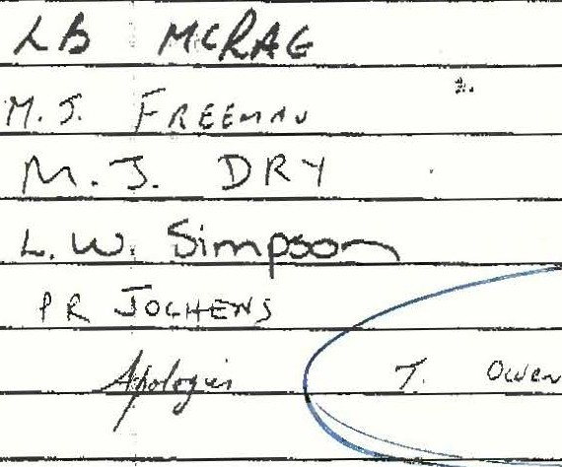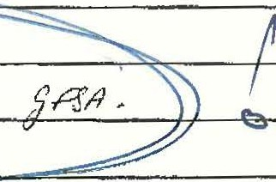

*It*

' l

*I(*

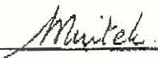

*7. C* . *L*,

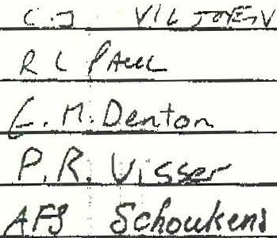

7-C *l*

*b1NTf)I*

**,r**

*L J* ***E.J-d.JMUl***









1989-04-24 15: 28 MnHEk RRHDBURG 011 7932413 P.06

**COUNCIL** FOR **MINERAL TECnN0LOGY PYR0METALLURGY DIVISION**

**SPONSOR'S MEE'l'ING ON l?R0JECT PLASMAFUME, 06687**

**DATE: :1989-04-18**

**TIME: '09.H.OO**

**VENUE: ,!MINWEK, P;'.'ROMETALLURGY MEETING ROOM 6620**

**AGENDA**

09HOO

09H05

09Hl0

Tea/Coffee

Welcome and Introduction Dr NA Barcza (Chainnan)

Presentation of results of project Mr L *J* Erasmus

**LASMAFUME,** Fhase 3 (50 kVA testwork)

09H25 toiscussion of r sults of proj4ct rLASMAFUME, Phase 3

09JUO

lOHlO

P.i..i:::t HLaLlvu vl 1:1;;::.ull.:$ ot project Mr A .I:'' :::; :::;cnou.Kens

**PLASMAFUME,** Phase **4 (3,2 MVA campaign)**

Discussion of results of project **PLASMAFUME,** and decision on q:ontinued work

10H30

10H40

llHOO

Presentation of preliminary Ge xtraction results from metal phase

General discussion

# Meeting ends

Mr PR Visser

TOTAL P.06

